Here are two sets of graphs. Each shows a pair of lines which are reflections of each other, one in the horizontal axis and one in the vertical axis.
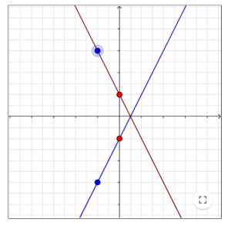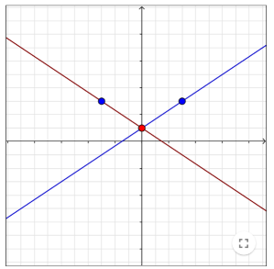
What can you say about the equations of two lines if one is a reflection of the other in the horizontal axis? What about a reflection in the vertical axis?
Below are the equations of sixteen straight lines. Each line has a partner, either its reflection in the horizontal axis or its reflection in the vertical axis. Without plotting any graphs, can you find all the pairs and say which axis they were reflected in?

